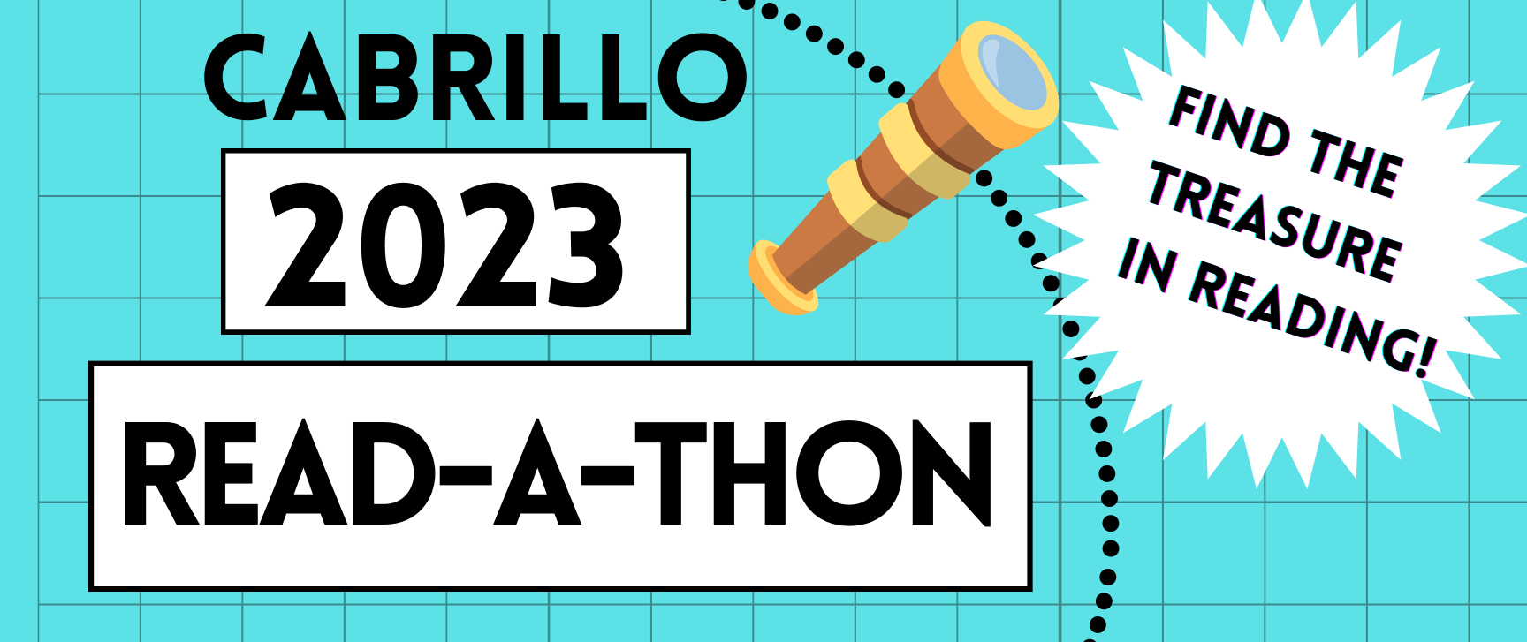

Dear Sponsor,
The Cabrillo Read-a-thon raises money to fund our school library and other school needs. The dates are April 17 through May 12, 2023.

Thank you very much for your pledge and your donation. If you would like a receipt for tax purposes, please write “RECEIPT” next to your name below. Make Read-a-thon Checks Payable To: Cabrillo PTO (Please write Readathon and the name of the student you are sponsoring in the memo line).

Name of Sponsor | Pledge  Per Hour, Minute, or Book | # of Hours, Minutes, or Books Read | $ Contributed | Date Collected
Examples
Ben Booklover | $1.00 | 20 | $20.00 | 05/13/23
1
2
3
4
5
6
7
8
9
10

Add another sheet if you get more sponsors. Money due back by May 15.

Cut Along This Line and Return Bottom Portion With Your Payment.
__________________________________________________________________________________________________

Student Name:_____________________________________________________ Amount:___________________

Teacher Name:_____________________________________________________ Room #:___________________

