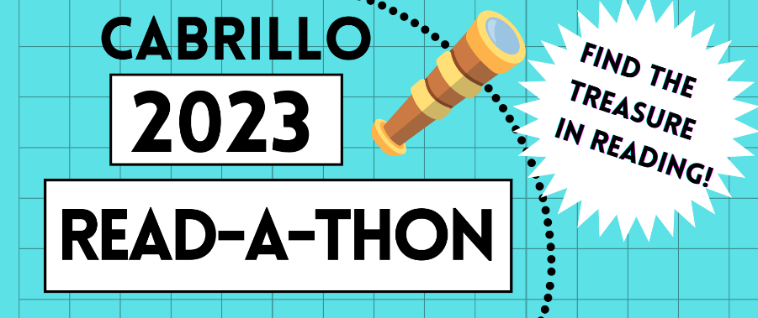

Optional Reading Log

Thank you for participating in the 2023 Cabrillo Read-a-thon. Our goal is to raise $12,000 or more to help fund our library and other school essentials.

To Participate:

- Visit https://cabrillopto.com/ for instructions on how to set up an online donation page at https://app.99pledges.com/fund/cabrillo24, or to print out additional paper reading logs or pledge sheets. Paper reading logs and pledge sheets are also available in the school office.

- Turn in all reading logs, pledge sheets, and donations to your classroom teacher or the school office by Monday, May 15. You do NOT need to turn in a paper reading log unless you want to be considered for the Top Reader prize (the student who reads the highest number of minutes for their grade).

- Email any questions to Rita Zoph and Ashley Larsen at readathon@cabrillopto.org.

Student Name: _________________________________________________________

Homeroom Teacher: ____________________________________________ Grade: ______

Week: (Circle One)

April 17 – April 21 April 24 – April 28 May 1 - 5 May 8 - 12

Write the number of minutes you read each day in the boxes below:
MONDAY | TUESDAY | WEDNESDAY | THURSDAY | FRIDAY | SATURDAY | SUNDAY

Total Number of Minutes Read for the Week: _________

Parent/Guardian Signature: ____________________________________________________

