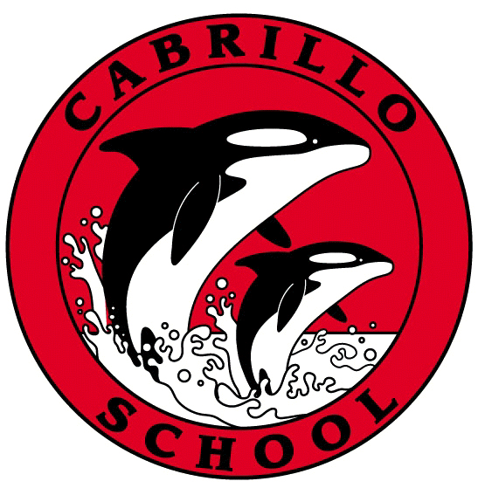
CABRILLO NEWSLETTER – MARCH 4, 2022
Hello Cabrillo Families –
I hope this newsletter finds you all well and healthy! We’ve had a terrific first week back from our President’s Week off. We did have two positive pools this week, in our “after break testing”. If this impacted your child’s classroom, you have already been notified by John Bartfield at the district office.

Today we held our first Family Day, since before the pandemic. For those of you who are new to Cabrillo, family day consists of one student per grade level (k-8) creating a family unit and doing activities together. This happens once a month at Cabrillo, and it was heart-warming to see our students happily working together. It is also a great leadership opportunity for our 7th and 8th graders as they assist the younger students with a project.

Cabrillo’s PTO is doing another See’s Chocolates fundraiser! Be on the lookout for the flyer to come home. The fundraiser runs from March 7 – 21. Candy is set to be delivered in mid-April, before spring break. If you have any questions please reach out to Michelle Ryan via phone or email. (650-303-7253, or michelleryan1215@gmail.com )

It is time to nominate a Cabrillo volunteer for the Elna Flynn Outstanding Volunteer Award. This award serves as peer recognition of outstanding volunteer activities within the Pacifica School District. Elna Flynn exemplified the word “volunteer” and gave countless hours, while raising her own four children. It is in her name that we recognize the value of the volunteer in striving for the successful education of our children. Please follow this link to nominate someone! https://docs.google.com/forms/d/e/1FAIpQLScPjVi4U__vLBv4OsG8jTH7jYznOU-y42q7oN_xLSR1SIeI0g/viewform?usp=sf_link

If your child is in 5th or 7th grade, please look at the health education flyers included. Puberty Talk is for 5th grade students, and Teen Talk is for 7th grade students. If you’d like to preview this material, or have questions about it, you may register for the free parent info sessions next Tuesday.

If your child’s teacher feels the need to hold a parent/teacher conference, you will be hearing from the teacher(s) this week. If you’d like a conference even though it is not required, please reach out and the teacher will schedule you! (Held on March 14 – 18 after 1:15).

Lastly, you may have gotten my email announcing the GREEN TEAM’S opportunity to help beautify Cabrillo. The flyer is attached again…the more the merrier!

Sincerely,
Annie

Annie Flores-Aikey
Principal

