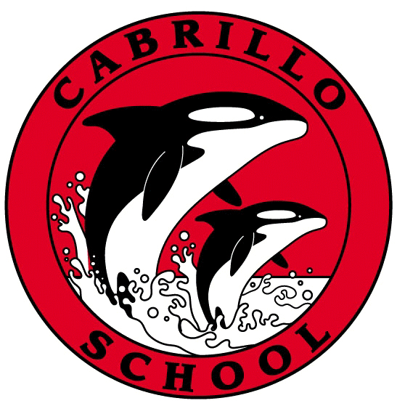
CABRILLO NEWSLETTER – MARCH 18, 2022

Hello Cabrillo Families –
I hope this newsletter finds you all well. Just a few announcements this week.

We're happy to announce that Cabrillo's 2022 Elna Flynn Award recipients are Ashley Larsen and Lisa Alasandro. Thank you to all who voted! Ashley has been a ‘Cabrillo Parent Volunteer Extraordinaire' for many years, working in the library and in the classroom, as well as leading music classes. Lisa has also been a volunteer in the Cabrillo community for several years, holding positions in the PTO as well as Class Liaison. She also organizes all aspects of art instruction - the art room, volunteers, curriculum, and supplies. Both Ashley and Lisa are always eager to help. Their selfless and tireless volunteer work in service to the Cabrillo community, makes them worthy recipients of the Elna Flynn award. We congratulate Ashley and Lisa and thank them for their dedication to Cabrillo! They will be formally recognized at the Elna Flynn Awards Banquet to be held on Friday, May 20.

If your child is in 6th grade, please turn in their T-Dap paperwork to the front office. Students may not start 7th grade without proof of the T-Dap.

See’s Chocolates - the fundraiser runs from March 7 – 21, and candy orders are due into the office on Monday, March 21st.

Yesterday, Mr. Softee was out front of Cabrillo, on Crespi from 1:30 – 4:00. There was a line all the way until 4pm. Thank you to the Cabrillo PTO fundraisers for setting this up! A portion of the proceeds come back to Cabrillo’s PTO and Mr. Softee was a big hit!

Thank you, Cabrillo families, for all the recess equipment that has continued to arrive at Cabrillo this week. Thank you from ALL of us at Cabrillo!

Sincerely,
Annie
Annie Flores-Aikey
Principal

