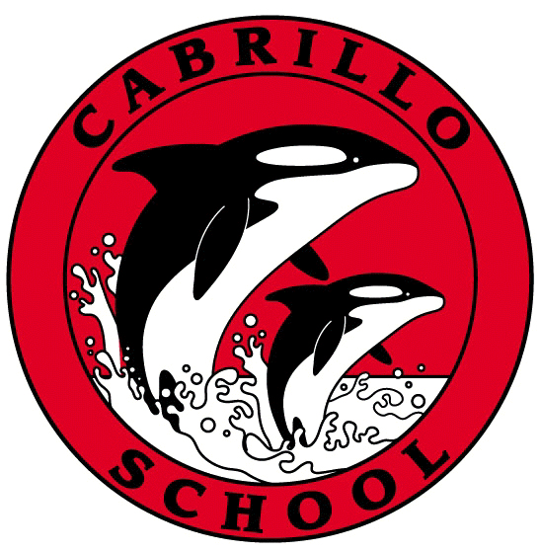
CABRILLO NEWSLETTER – MARCH 11, 2022
Hello Cabrillo Families –
I hope this newsletter finds you all well. Next week will be fun for Cabrillo students! Monday, March 14th is Pi Day and the 2nd – 8th graders will be having a pie eating contest as a lunchtime activity. The kindergarteners and first graders will be focusing on St. Patrick’s Day. They have built Leprechaun Traps, and are hoping for some surprises! On Thursday, we are encouraging all students to wear green in honor of St. Patrick’s Day! Those who do will receive an Orca Power ticket.

Great news! The Pacifica Sharp Park Library is now open 7 days a week! Other San Mateo libraries are extending their hours too. Extended hours are:
- Monday – Thursday: 10am – 8pm
- Friday – Sunday: 10am – 5pm
The Sanchez Library hours are: Tues & Thurs 12-5pm & Saturdays 11am-5pm

As announced last week, our PTO is doing another See’s Chocolates fundraiser! The fundraiser runs from March 7 – 21. Candy is set to be delivered before spring break. If you have any questions please reach out to Michelle Ryan via phone or email @ 650-303-7253, or michelleryan1215@gmail.com .

Thank you to those of you who nominated someone for the Elna Flynn Outstanding Volunteer Award. This award serves as peer recognition of outstanding volunteer activities within the Pacifica School District. It is in her name that we recognize the value of the volunteer in striving for the successful education of our children. The ballot is being finalized, so please check the Sunday/Monday version of the newsletter so you can vote!

Parent/Teacher Conferences are next week and we are having “early release” all week to accommodate this. This runs from March 14 – March 18th.

This week the Pacifica School Board voted to require masks in our schools until Friday, March 25th. This means that on Monday, March 28th masks are optional. We know this is a divisive topic and I am getting emails for and against this vote. So, all I will say on the matter is that the school board requires, and will receive, my support.

Thank you, Cabrillo families, for all the recess equipment that has been donated to Cabrillo this week. It is heartwarming to see the immediate response when we put out a request for recess equipment for our students. Thank you from ALL of us at Cabrillo!

Sincerely,
Annie
Annie Flores-Aikey
Principal

